**Cloud computing –**

This is a mechanism where the client has the ability take control of their resources stored within the internet in a remote location. This means that a third-party entity must be involved into this process to store the data in their servers. Due to the, the cause to data protection may arise as the client trusts the cloud providers security and ethics.

Cloud computing can be very resourceful and powerful to handle data flow in a process like in this supermarket chain, where the head office operator will access the cloud infrastructure to operate their equipment and data. The cloud service will be the central storage unit for this data. In addition to the storing the data, the client can process this data within this cloud infrastructure. This will allow the client to save their own resources and gain a greater output margin.

Some of these cloud service providers are Amazon Web Services (AWS), Microsoft Azure, Google Cloud Platform. These are some of the leading cloud service providers that engaging on the three main types of cloud services,

Software as a Service (Saas) –

This is software provider as a service though the cloud infrastructure where the client does not have to use their own resources to operate and will only require a fully functioning web browser and network connectivity.

Examples: Google Apps and Dropbox

Platform as a Service (Paas) –

Providing a platform via the internet for the client. This involves both hardware and software.

Example: Windows Azura, OpenSwift

Infrastructure as a Service (Iaas) –

This is providing an infrastructure over the internet. The client will be handling storage, virtualization and networking, and the payment strategy would be pay-as-you-go, meaning that the client has to pay the cost for the amount of resources they use only.

Example: Google Compute Engine (GCE), Amazon Elastic Compute Cloud

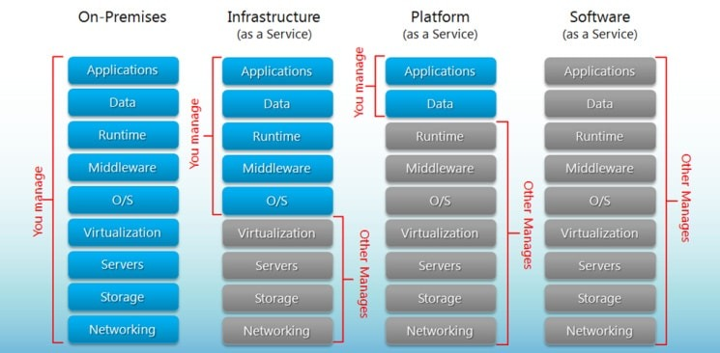

Resource usability for the types of cloud services (SaaS, PaaS, IaaS) (Hou, 2020)

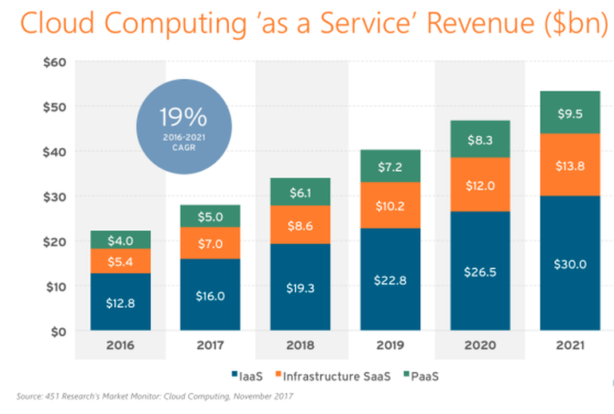

Illustrations of the cloud computing services revenue for the current period. (Ranger, 2020)

Currently the revenue gained from cloud services are rising than the rate the analysts has predicted. This means that nowadays many clients reply on cloud services as they provide the more resources for a lower cost.

Main Advantages of Cloud Computing

* Cost Savings – This one of the most beneficial factors of cloud computing is the cost as from the client’s perspective the physical hardware and maintaining this equipment is not an issue. These entities are primarily managed by the cloud service provider.
* High Speed Connectivity – Within a matter of several clicks the client’s product can be operational within the cloud platform. This allows the clients to get an instance response about the status of the cloud service.
* Data Backup – Backing up data is important incase a data corruption occurs. With cloud services it is easier to backup the data as it won’t take additional time like when running these services on-premises.
* Mobility – When working with cloud services, these resources can be accessed from anywhere as long as there is an internet connection available. This would be useful for clients to access their needs remotely from anywhere.

Main Disadvantages of Cloud Computing

* Performance Allocation – When using cloud services, the resources are shared among other clients and it the providers unable to allocate additional processing power some users will experience a latency.
* Potential Risk of Cyber Attack – Since the cloud services are accessed via the internet there is chance of getting security threats and attacks from hackers. But if the cloud service provider can handle the threat or attack without causing any endangering to the client’s data, this risk will not be an issue. But for providers that engage less in security protection this factor would be risky.
* Downtime – When services are running on a cloud system, there are instance where the physical server must be maintained with the latest checkups and updates. This would cause the client to experience lower speed in connectivity or the services would be unable for a certain period of time.

**In-House Servers –**

In this mechanism, the servers are stored on the same premises as the client administrators. This option allows the employees to operate their data flow hands-on and if some equipment malfunctional they can maintain it instantly.

Main Advantages of In-House Servers –

* Full Control – All the data flowing through is handled only by the clients and this allows for the client to take the rightful decision when it comes to how the servers must be operated at a significant amount of time.
* Security – There are no third parties involved to handle the data flow. Only the personal that has the ownership of the data will operate on the data flow. This is highly important for companies that handle sensitive information in their servers.
* Internet Connectivity – Since the server located within the premises there is no need for the use of the internet to access these servers. They can use a private local area network that allows access within the premise only. This means that there won’t be any network latency and it is impossible for any unauthorized entity like a hacker to intercept into the internal network.

Main Disadvantages of In-House Servers –

* Cost – All the necessary equipment must be installed and maintained by the clients. Also additionally skilled workers to operate these servers is required.
* Space Allocation – Operating servers takes a lot of physical space and this allocated space must be in a suitable for powering and cooling the systems.
* Disaster Risk – On premises installation can be risk for the data loss as natural disasters could endanger the server physically.

**Bibliography**

Hou, T., 2020. *Iaas Vs Paas Vs Saas: What You Need To Know + Examples (2018)*. [online] The BigCommerce Blog. Available at: <https://www.bigcommerce.com/blog/saas-vs-paas-vs-iaas/#the-key-differences-between-on-premise-saas-paas-iaas> [Accessed 26 April 2020].

Ranger, S., 2020. *What Is Cloud Computing? Everything You Need To Know About The Cloud, Explained | Zdnet*. [online] ZDNet. Available at: <https://www.zdnet.com/article/what-is-cloud-computing-everything-you-need-to-know-from-public-and-private-cloud-to-software-as-a/> [Accessed 26 April 2020].